The mash-up application I designed is called the “weather info”. It uses the google charts, yahoo weather, USA today weather and is mainly done using html and javascript.

Since it’s in the format of a single html file, right click on the file and go to open with and then select firefox to view the application.

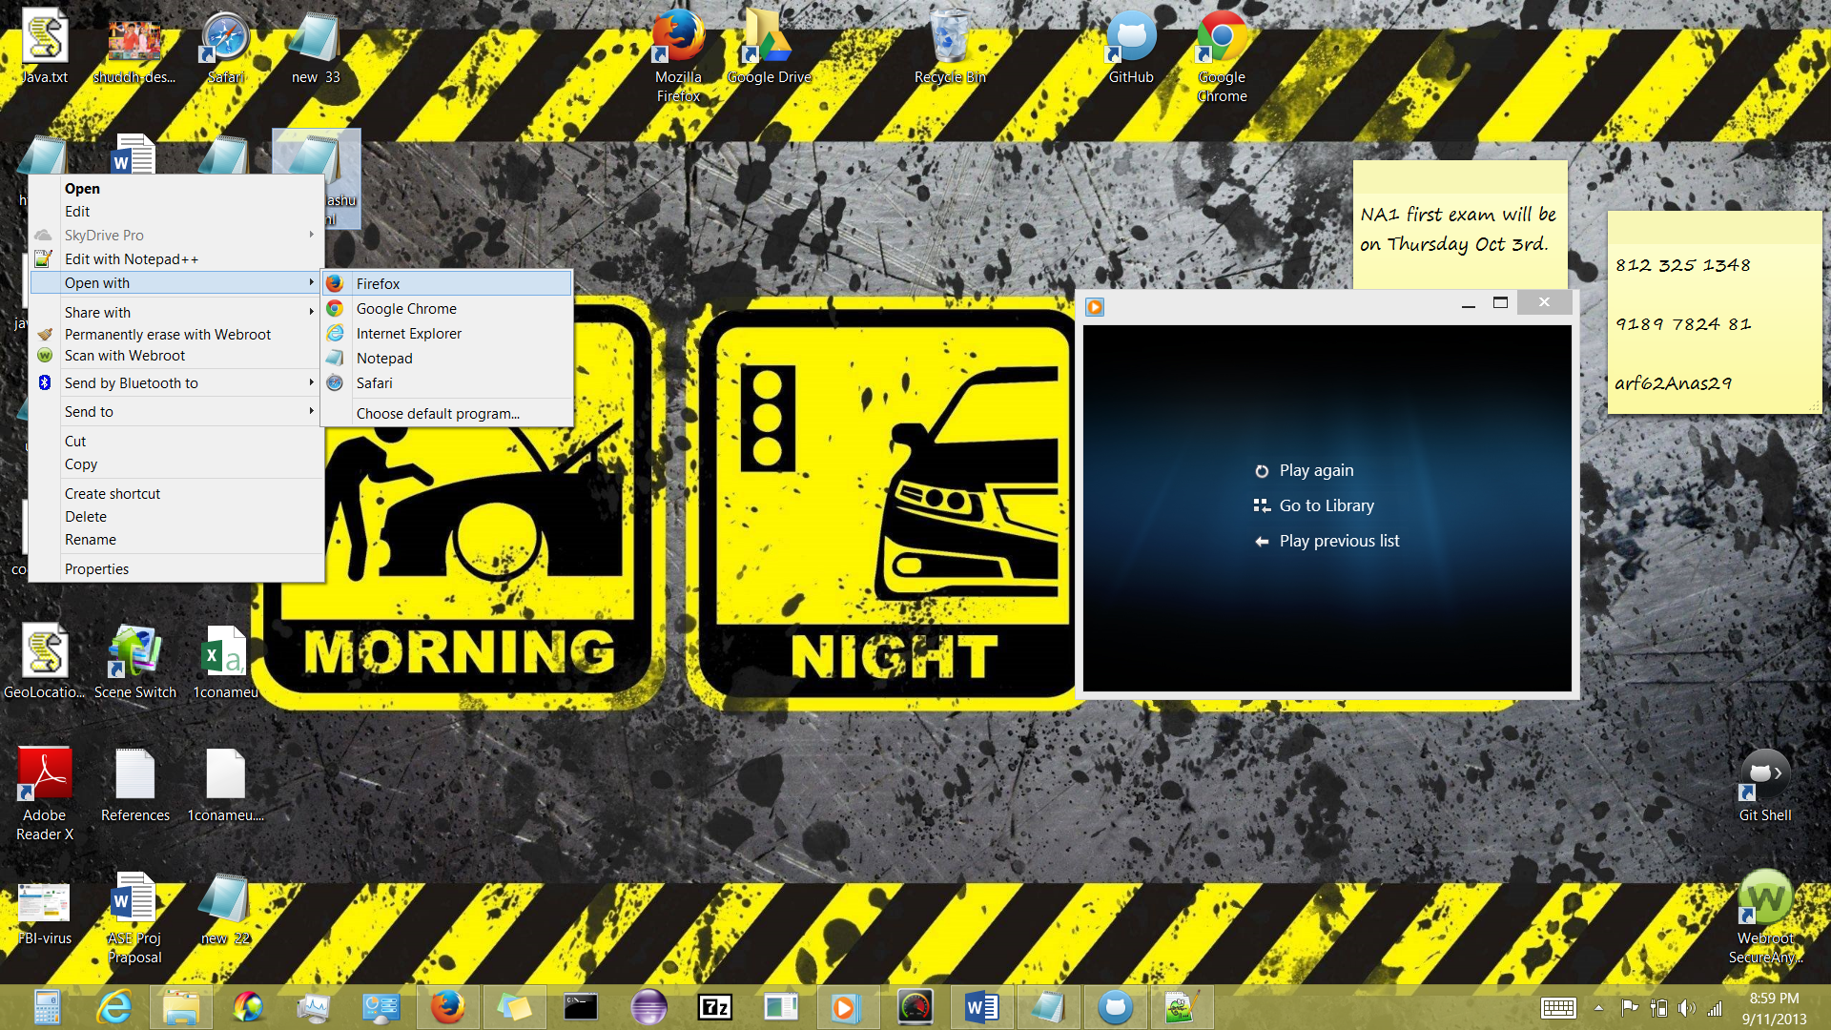

Then the following page will open in the firefox browser then click on ShareLocation.

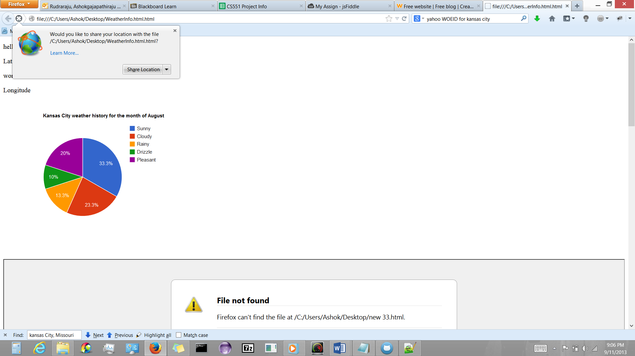

For the first time only the weather pie chart is visible.

Toggle down in the page and click on both of the “Click to Load” links.

This will make the page transform completely and show weather data from USA Today and yahoo weather in one page along with the pie chart, as shown below.

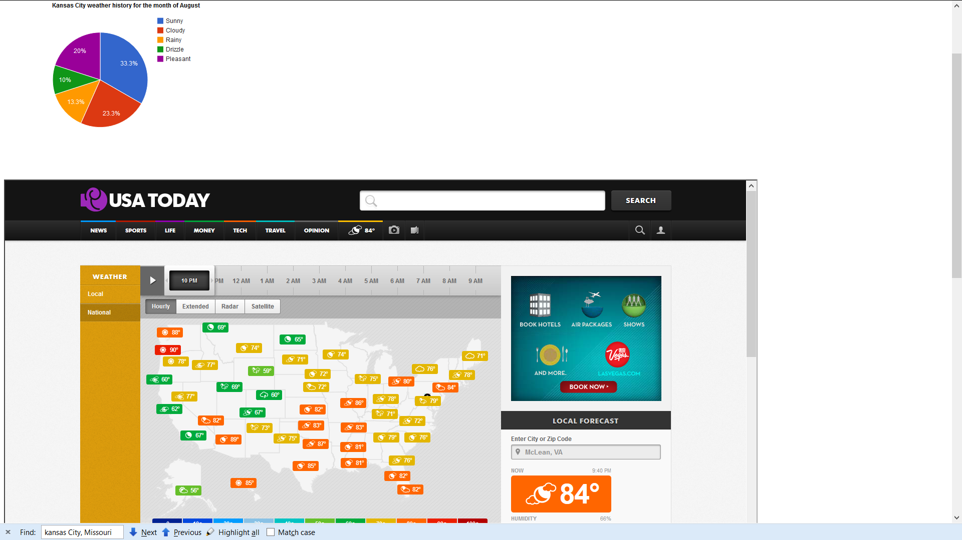

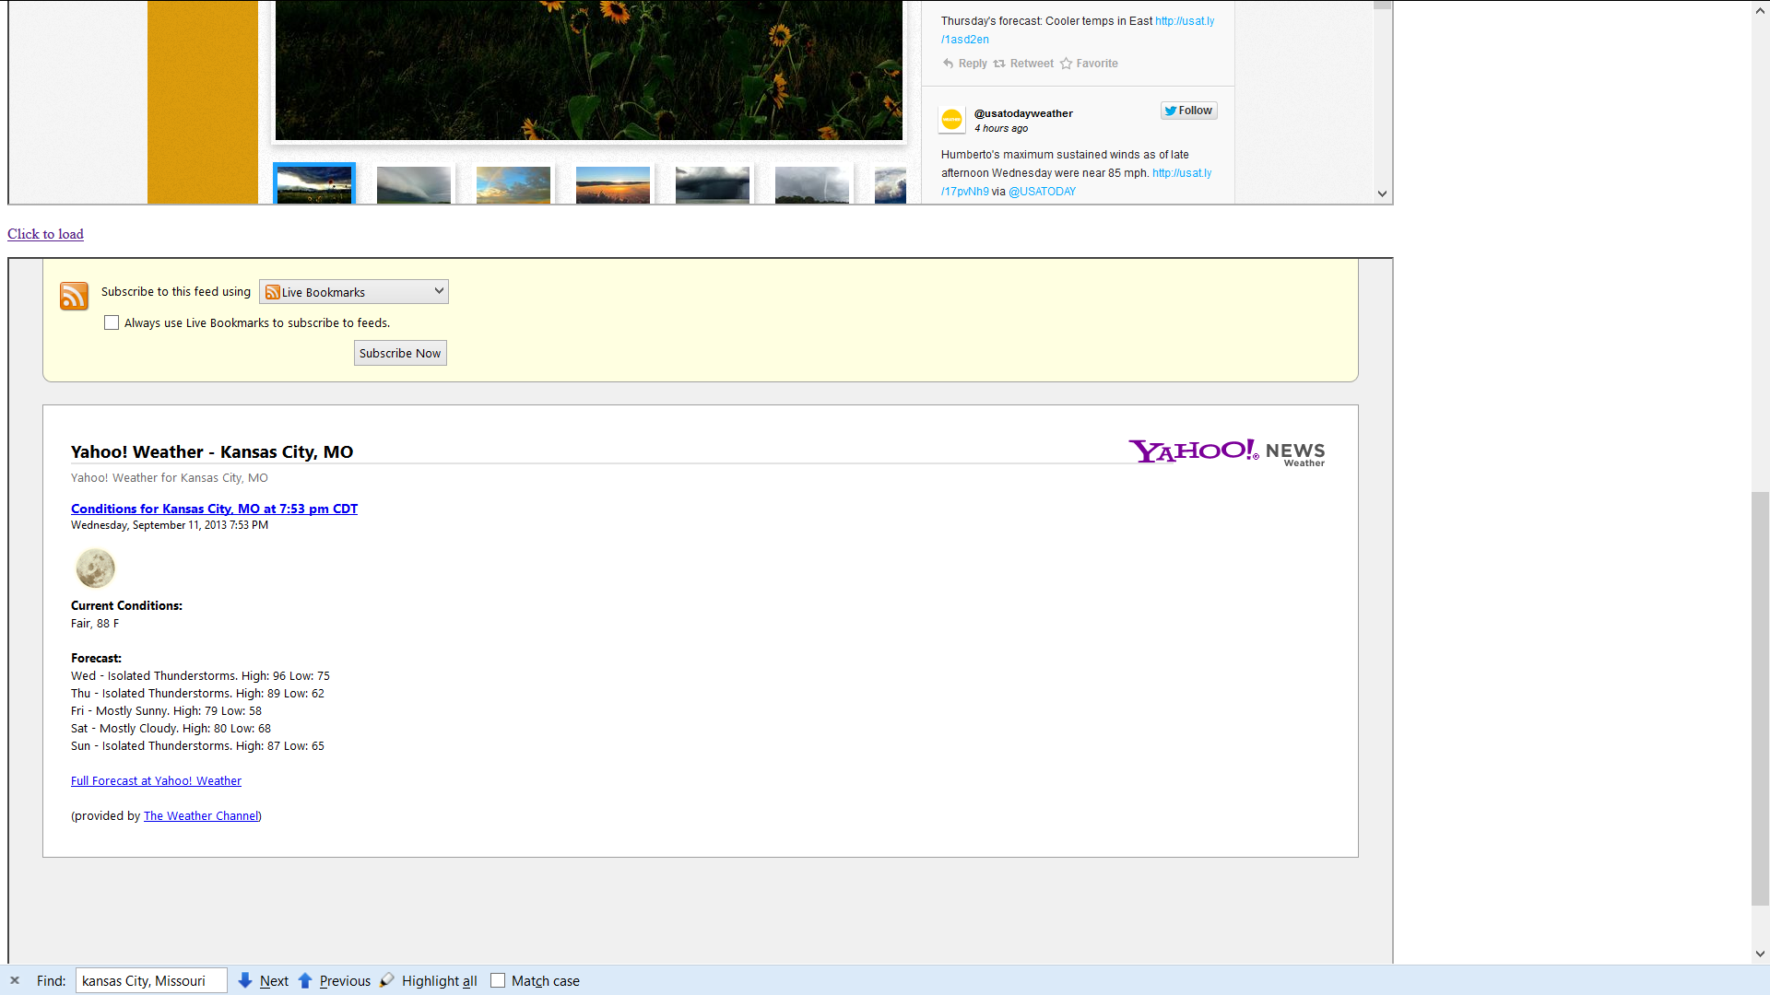

Also in the upper left corner of the page the app shows the user’s current location (latitude, longitude) automatically.

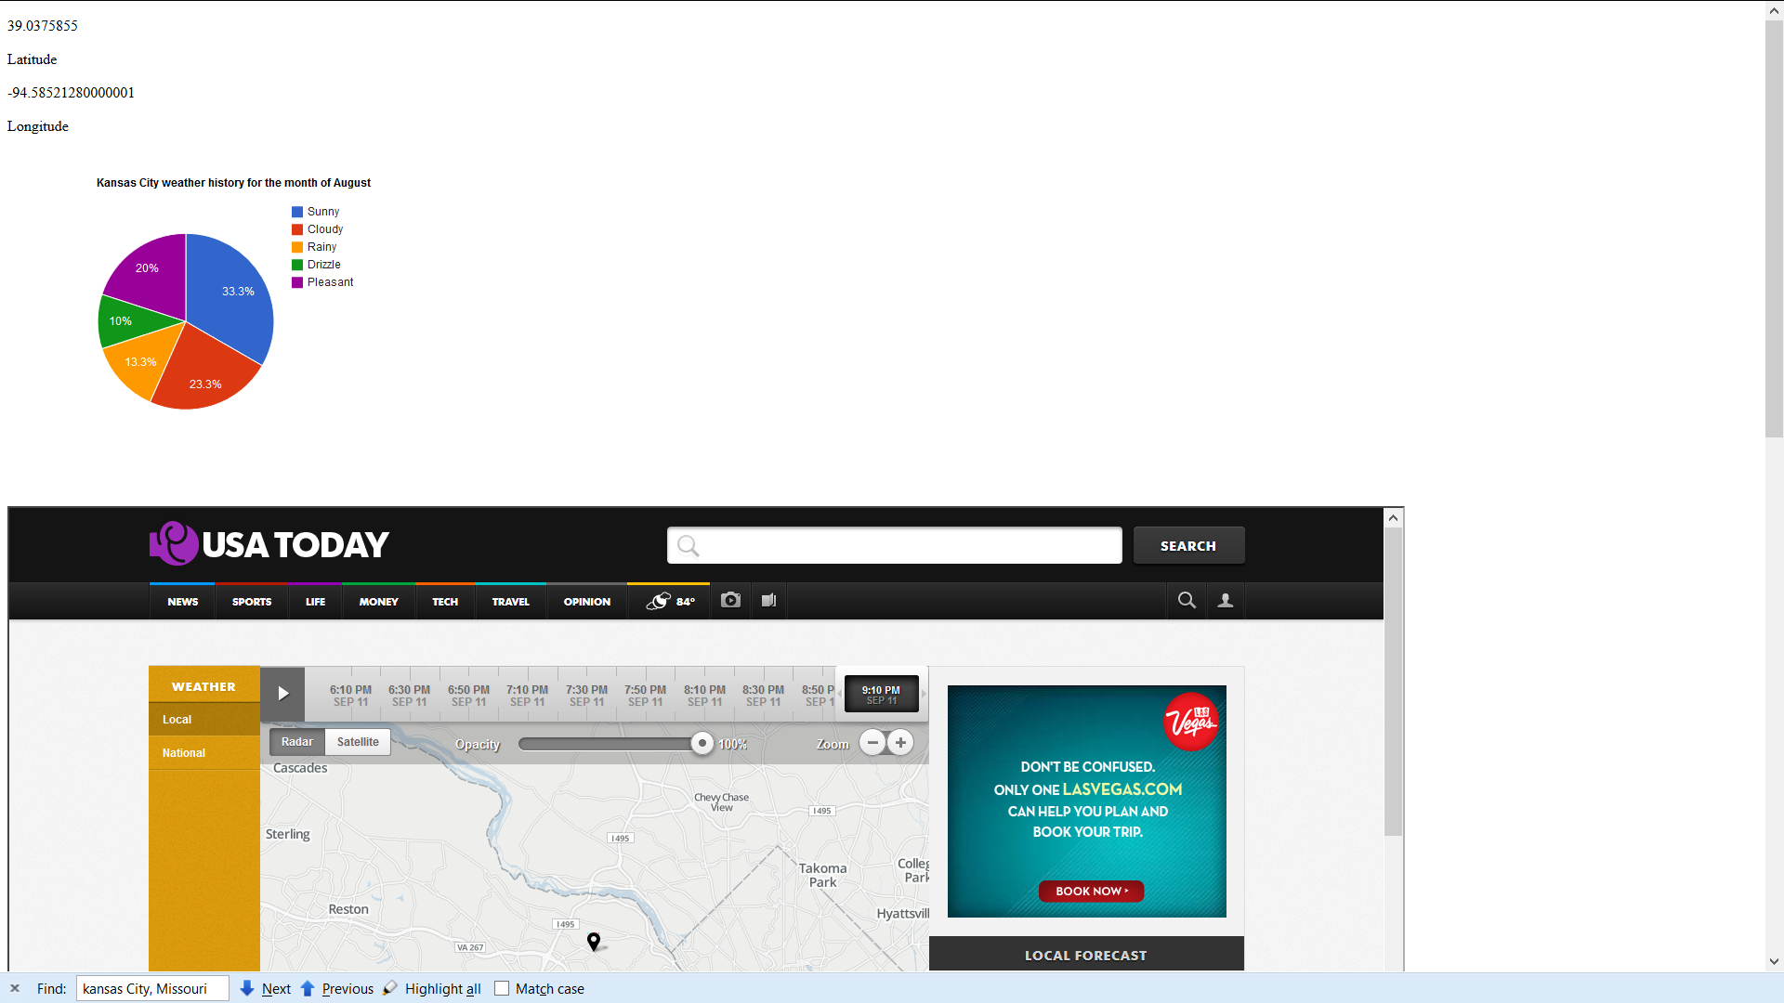

**Reference:**

W3schools: http://www.w3schools.com/

Yahoo weather api: http://developer.yahoo.com/weather/#request

Google charts api: https://developers.google.com/chart/?hl=en

Google maps api: https://developers.google.com/maps/documentation/javascript/

Usa today: http://www.usatoday.com/weather/